PRESS RELEASE

FOR IMMEDIATE RELEASE

International QRIS Provides Easy Transactions for Foreign Tourists

Batam, Kominfo Newsroom - Economic observer from Batam International University (UIB) of the Riau Archipelago province, Suyono, said that cross-border QRIS provides easy payment solution for transactions made by foreign tourists when shopping.

Suyono said the implementation of cross-border Quick Response Code Indonesian Standard (QRIS) is aimed at reducing cash transactions. In addition, business actors, including both SMEs and large businesses, in countries implementing QRIS in their payment system will get many benefits and conveniences.

"Foreign tourists don’t need currency convertion, just scan the QR, and transaction value will be auto,atomatically adjusted to the local currency exchange rate," said Suyono when contacted in Batam, Saturday (4/22).

He explained that as of December 2022, the number of QRIS users had reached 28.7 million merchants and 90 percent of them were MSME actors.

"The number of transactions has reached 1 billion, worth nearly Rp100 trillion. This proves that using QRIS facilitated not only consumers but also businesses," he said.

Suyono added that with the cross-border QRIS policy, it is hoped that the number of merchants will increase.

On the other hand, when it is involving foreign consumers, business actors must improve their product quality, especially for MSME products most sought after by tourists such as food, beverages, clothing, and crafts.

"I'm sure BI already has a roadmap for this (cross-border QRIS), and it’ll be integrated, because the initial goal of implementing QRIS is to optimize the non-cash payment system," said Suyono.

Previously, local micro, small and medium enterprises (MSMEs) in Batam City were ready to implement the cross-border Quick Response Code Indonesian Standard (QRIS) between ASEAN countries.

QRIS is a payment standardization system using the QR Code method set by Bank Indonesia to make easier, faster, and more secure transaction process using the QR Code.

Local MSME actor Deby on Saturday said that the future policy to implement cross-border QRIS will make transactions easier.

"God willing, we are ready for this, because it makes transactions easier. But so far there have never been any problems in transactions with foreigners who bought my products in expos or exhibitions, because usually they use cash and brought rupiah currency too," she said . (Jessica/ TR/Elvira)

***

Director General of Public Information and Communications of the Ministry of Communications and Informatics - Usman Kansong (0816785320)

Get other information at https://infopublik.id

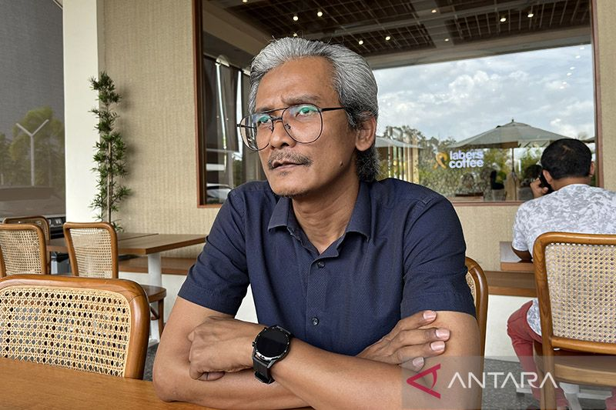

Batam Economist from Batam International University (UIB) of the Riau Archipelago province, Suyono. ANTARA/Jessica/am

***

